**CHAPTER 1**

**INTRODUCTION**

**1.1** **Introduction**

“Intelligent Tourist Recommendation System” is a recommendation system, which generally recommends places which are according to the user’s query. This project is an attempt to help visitors by giving them proper information about the destinations places for their visiting purpose.

Travelling can be fun and difficult at the same time. People loves to travel as much as they can. But sometimes, their desire of travelling as much as they can, just lost somewhere in their dreams only because they don’t have access to any guidance for that particular place and information related to it. This Intelligent Tourist Information System will help those people who love travelling or those even too, who wish to travel at some new place alone or without any prior information about that place.

Searching is the main task performed in this system, which recommends the users based on the key words used to search the information. Recommendation of destinations is based on main criteria such as: Cost, Distance, Security, Infrastructure, Natural sights and others. The system displays the destinations as per user requirements and previous choices.

Thus, this system “Intelligent Tourist Recommendation System” is the web application which helps visitors to get proper and quick information regarding different places or destinations.

**1.2** **Problem Definition**

People now a day are being more specific to any subject matter. They expect detailed and perfect information of whether it is of sports, food, news, politics or any travel related problems. Visitors have difficulties to find information regarding their destinations. They need to spend lot of time in searching the information regarding the proper place for the visiting purpose.

The future of the existing system has to be seen as one of the continuous changes, where the complexities and the quantities are being grown in the daily basis. The existing system is required to provide a useable and well managed layout and the smoothness in the tourist information system with the minimum requirements and minimum budget.

In existing Intelligent Tourist Information System, the traveler has to search a lot of websites or have to ask to people which they find in between their way, in order to get the knowledge of the routes or information about the particular place. Existing Intelligent Tourist Recommendation System will take a lot of time and thus the traveler have to face even such a situation when they don’t have any time and thus they have to limit themselves into only few places to visit.

**1.3** **Objectives**

The primary purpose of this project is to serve people through web-based tourism services.

The major purpose of the intelligent tourist recommendation system is:

* To implement AI in tourism,
* To reduce the time and cost of the travel,
* To make clients more confident about the trip,
* To guide the clients during their trip,
* To help those who are not familiar with travelling.

**1.4** **Scope and Limitation**

This website provides a better platform for any user or people who are seeking for places for visiting purpose according to their requirements such as cost, environment, security, distance and many more. The focus of this system is to recommend the best outcomes while the user of the system passes input. “Intelligent Tourist Recommendation System” proceed the searching process by using the keywords, input by users, and matching keywords stored in the database of the system. It provides quick search of information from the database and display it to users.

**Cosine Similarity**

We use Cosine Similarity algorithm for processing information and produce output. Cosine similarity method measures the similarity between two objects based on an angle formed by two objects in vector space. The cosine similarity ranges between 0 and 1 if the values in vectors are positive. A cosine similarity of 1 represents complete similarity between two objects and that of 0 represents complete dissimilarity. The user input contains

The formula for calculation is:

Cos (a, b) = (a.b)/ (||a||×||b||)

where, ||a|| and ||b|| are the Euclidean norms of vectors a and b, respectively, and a. b is dot product between vectors a and b.

**Limitations**

After pre-study of the project, we found that we might face some problems during the implementation process of this project. They may reduce the quality of result when user searches the information in the system. Some of the limitations are:

* It is difficult to rank places in numbers accurately (due to different perception of peoples).
* No option for reviewing the places.
* There is no appropriate range to rank places.

**CHAPTER 2**

**REQUIREMENT ANALYSIS AND FEASIBILITY STUDY**

**2.1** **Literature Review**

Over the years, tourism has continued to gain massive interest at a global scale. It is a major foreign exchange earner for a good number of advanced and emerging economies. It is also true that information explosion makes it cumbersome times to access relevant information to enhance decision making. This has given rise to the emergence of intelligent systems or mechanisms that facilitate quick access to relevant content found in the Internet [1,2].

For developing countries like Nigeria, tourism is one of the untapped but potentially big income generator. There are about 142 tourist destinations that spread across the 36 states of the federal republic of Nigeria. Whereas some exist naturally, others are manmade [3].

In this era that has witnessed rapid advances in information technology, information overload has become a serious problem to those seeking for information online. Recently, intelligent search mechanisms have been deployed on the web that shows that the problem of information overload can be partially eliminated by providing a platform with more intelligence to assist tourists in the search for relevant information [4].

Google.com is an example of an intelligent search engine that helps users with information and another class of intelligent system that has proven relevant in addressing the problem of information overload are recommender systems [5].

In the aspect of tourism, Internet and web technologies have made more readily available information on tourist locations, accommodations, transportation, shopping, food, festivals, and other attractions, thus improving tourism experience [6].

**2.2** **Requirement Analysis**

While developing a system and before implementing it, it is necessary to analyze the whole system requirements. It is categorized into mainly two parts, namely: functional and non-functional requirements.

**2.2.1** **Functional Requirements**

A functional requirement describes what a software system should do when it is given input. Some of the functional requirements are given below:

* Information about the different places.
* Users can provide their requirement as input.
* Admin can add places, edit places, and delete places.
* Users gets the recommendation.

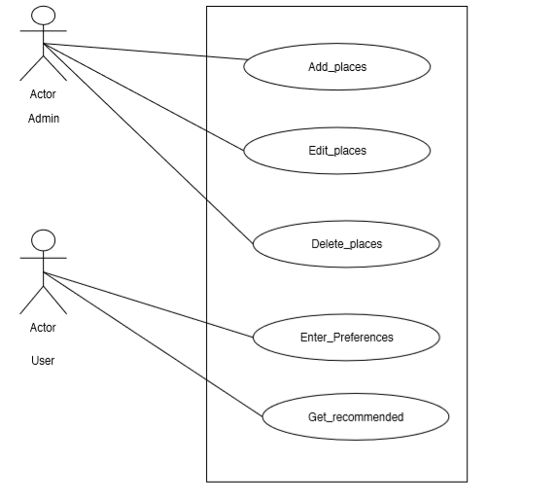



*Fig 2.1: - Use case diagram of proposed system*

**2.2.2** **Non-functional Requirements**

A non-functional requirement describes how the system performs a certain function. Non-functional requirements generally specify the system’s quality attributes or characteristics.

Typical non-functional requirements include:

* This system uses vector space method to compare and produce the result and takes short period to display the result.
* The system should be capable of supporting large number of visitors.
* The users should follow the input pattern to search the destinations.

**2.3** **Feasibility Analysis**

Feasibility analysis is a part of system analysis carried to confirm that the system being developing is actually feasible or not. This is the phase where any system designers are able to know whether to start the project or not.

We performed some study and analyzed the system and get to know that it is feasible to make the system. Mainly four types of feasibility studies were done with this system analysis, namely: Economic feasibility, Operational feasibility, Technical feasibility and Schedule Feasibility.

**2.3.1** **Economic Feasibility**

Developing and deploying this system has a very little economical cost. All the resources required to develop this system are computers and some hospital information.

For development, PCs that support any Operating System with some applications is sufficient. For deployment, a smart phone or PC with internet is required. During data collection too, not much cost was spent and same with time as well. Further, it does not cost much to develop and access this system and hence, we can say it is economically feasible to develop the system.

**2.3.2** **Operational Feasibility**

Proposed project is beneficial only if they are feasible into real world implemented system, which will meet the user requirements. This system provides a simple user interface, which can be easily used by any type of users having basic idea of using smart

phones and PCs. This system will provide correct results according to the way the system needs to do. Hence, this system is operationally feasible too.

**2.3.3** **Technical Feasibility**

We can say that the current web application, we are building, is technically feasible. This system is built using simple programming language and design, which can be used by any users and can get better place, which contain information regarding different services. It will run on all the existing web browsers with latest version and even in smart phones.

**2.3.4** **Schedule Feasibility**

A system is said to be scheduled feasible if it is implemented within the planned scheduled. We carried out the study on how much it will take to complete the task after studying the requirements and proposed plan.

We proposed the rough timeline so that we it would help us to perform our different project activities. Following Gantt chart shows the proposed schedule to perform the project:



*Fig 2.2: - Gantt chart for the proposed system*

Thus, creating the schedule and working on it makes it easier for developers to finish the project on time. Hence, this project is feasible if we completed this task within the designed Gantt chart.

**CHAPTER 3**

**SYSTEM DESIGN AND FLOW DIAGRAMS**

**3.1** **System Design**

This phase contains diagrams and designs that help to know about the overall process in the system. Some of the designs are described below:

**3.1.1** **Database Schema Design**

Database Schema is the overall representation of database tables in a way that represents all the co-relations between them.

The database schema design of our project is given below:

**3.1.1.1 Packages Table**

|  |  |
| --- | --- |
| Attributes | Data Types |
| sn(pk) | integer(11) |
| place | varchar(200) |
| image | varchar(200) |
| weather | float |
| crowd | float |
| infrastructure | float |
| simsar | float |
| cost | float |
| distance | float |
| security | float |

**3.1.1.2 Users Table**

|  |  |
| --- | --- |
| Attributes | Data Types |
| id(pk) | int(11) |
| username | varchar(255) |
| password | varchar(255) |
| role | varchar(50) |

**3.2 Block Diagram**

A block diagram is a diagram showing in schematic form the general arrangement of the parts or components of a system or process. There are four components in the design. First component is the user who provides their requirements, the second component is the system that takes user input and provides the result to user, the third component is the algorithm that calculates the cosine value and matches with the stored result and finally the last component is the database where the data are stored. Here, after the login in the system, the tasks that are done in the system are represented below:

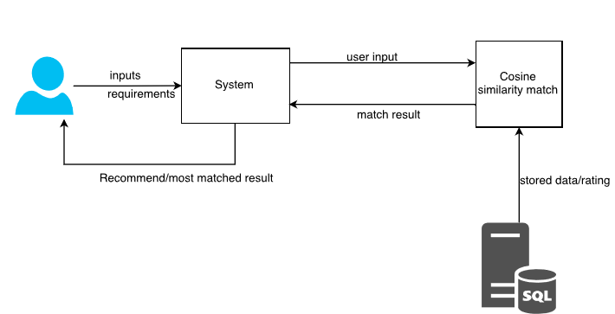

*Fig 3.2: - Block Diagram of the system*

**3.3** **Flow Diagram**

The flow diagram is the way of representing the working process in the system where every process is decomposed in order to show clear flow of data in the system.

Here, in this system we have decomposed some of the processes so that it can give the give the information about data flow in the system.

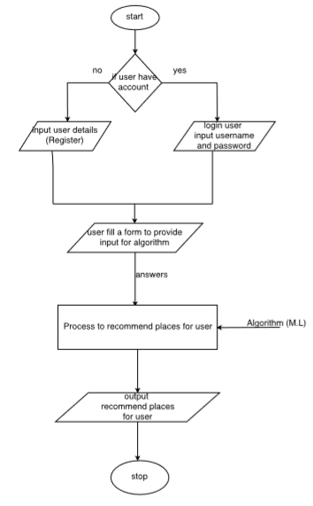

*Fig 3.3: - Flow Diagram of the system*

**CHAPTER 4**

**IMPLEMENTATION AND TESTING**

**4.1** **Background Study**

In order to design this system, it is necessary to know some background knowledge of basic terms in programming. This project is done using PHP programming language and is performed over MVC Framework. The design portion of this project is made using CSS, vue.js, Bootstrap and JQuery.

So, the team members who are going to design this system needs to know the mentioned skills. And for the system users, there is no need to do the background study of any code or designing techniques. They only require is to know the basic usage of system with proper interaction.

**4.2** **Implementation Tools**

This is the phase where we are actually building the system. Firstly, the whole information that we gathered are studied, analyzed and then it was processed to build an actual system.

Different tools and technologies that we have used are given below:

**4.2.1** **HTML, CSS, BOOTSTRAP**

In this system, HTML is used to display the data in the web browser. Interactive forms are created using HTML codes. Many pages include HTML codes that also links other pages and codes. In the header section of HTML tag, designing link are places so that it is accessed in every page.

CSS, used as a designing tool, helps the interface look much better. Bootstrap, so called framework of CSS, contains various classes for designing the interface. It gives better shape to CSS and make the page more interactive and good looking. We have used Bootstrap classes to make nice frame of design.

**4.2.2** **PHP and Sublime Text**

We have used PHP, as a server-side scripting language, to build this project using the well-known PHP framework i.e. MVC framework, which is easier and better way to create a project.

For designing and coding, we have used popular text editor called Sublime text which makes more easier to do tasks, have better interface and easy to communicates with the different sub folders and pages.

**4.2.3** **MySQL and XAMPP Server**

We use MySQL as a database language for storing and communicating information with the database. We have created altogether two tables and some of them relate to each other.

In this system, we have used XAMPP server to connect with the database.

**4.2.4** **Edraw Max**

In the system structuring part of the report organization, we have drawn Use Case Diagram, Block Diagram and Flow Diagram with the help of the case tool called Edraw Max. It is an easy tool for constructing such diagrams providing necessary images, shapes etc. It also provides some standards that are available in designing.

**4.3** **Algorithm Implementation**

We have used Cosine Similarity algorithm for processing information and produce output. Cosine similarity method measures the similarity between two objects based on an angle formed by two objects in vector space. The cosine similarity ranges between 0 and 1 if the values in vectors are positive. A cosine similarity of 1 represents complete similarity between two objects and that of 0 represents complete dissimilarity. The user input contains weather, crowd, infrastructure, water resources, cost, distance and security.

The formula for calculation is:

Cos (a, b) = (a.b)/ (||a||×||b||)

where,

||a|| and ||b|| are the Euclidean norms of vectors a and b, respectively, and a. b is dot product between vectors a and b.

The following code is used implement this algorithm:

class CosinesimilarityController {

public function similarity(array $vec1, array $vec2) {

return $this->_dotProduct($vec1, $vec2) / ($this->_absVector($vec1) * $this->_absVector($vec2));

}

protected function _dotProduct(array $vec1, array $vec2) {

$result = 0;

foreach (array_keys($vec1) as $key1) {

foreach (array_keys($vec2) as $key2) {

if ($key1 === $key2) $result += $vec1[$key1] * $vec2[$key2];

}

}

return $result;

}

protected function _absVector(array $vec) {

$result = 0;

foreach (array_values($vec) as $value) {

$result += $value * $value;

}

return sqrt($result);

}

}

**4.4** **Testing**

Various types of testing procedures were performed in order to check the working mechanism and correctness of the system. Some of the types of testing that we did attempt are described below:

**4.4.1** **Unit Testing**

We have tested each modules of this system in order to check the correctness of the output. Firstly, we found many errors and then it was resolved stepwise. Hence, this test was successful.

For this testing, we test for login section by registering new users and providing access to use the system. We added places and ratings in the database. Hence, unit testing is done.

**4.4.2** **Integration Testing**

We used this testing process to verify the functional, performance, and reliability between the modules that are integrated. For this test, we combined some modules of task like inserting weather, crowd, infrastructure, water resources, cost, distance and security. Correct output is obtained through this test.

**4.4.3** **System Testing**

In this testing process, we assembled all the components of the system at a common place and created test. Inputs were given to the system which includes characteristics like weather, crowd, infrastructure, water resources, cost, distance, security and the recommendation algorithm used in the system produced the output along with the recommended destination places. Hence system testing is carried out.

**CHAPTER 5**

**MAINTENANCE AND SUPPORT**

Every system requires maintenance and supports in order to get proper shape. Maintaining websites is not an easy task to do. It requires regular checkups and troubleshoots. In this system, we will perform checking of the system in a regular basis. Regular backups will be stored in order to track the data flow in the system. Many functions and algorithms will be tested in order to improve the performance of the system. Security methods will be applied to make the system secure.

In the other hand, setting up the automated information systems, such as searchable frequently-asked-question (FAQ) databases or newsletters can be added to improve the support for client. Mail services can be added to keep in touch with the information source.

**CHAPTER 6**

**CONCLUSION AND RECOMMENDATION**

**6.1** **Conclusion**

Hence, we have developed web-based application named as “Intelligent Tourist Recommendation System”. Our project facilitates people to search for a destination to visit. Based on the user’s input parameter the system recommends the destinations to user. The recommendation system tries to suggest the places where the user wants to go.

Recommendation systems have become extremely common in recent years, and are applied in a variety of applications. In our system, various destination is recommended to the users. The recommendation of the destination to the users makes them easy to find the place to enjoy their vacations. Hence, they feel comfortable to visit the website repeatedly.

**6.2** **Recommendation**

Here, the project developed is just for providing the information of certain areas in a country. Here, this system contains only the limited number of data for the particular region. This system may not give more accurate results and the recommended information may not meet the user needs.

This project can be enlarged and make more accurate if more research is done and more effective functions are added. For this, more effective recommendation algorithms should be used, along with the collection of more information so that this system could be accessed throughout country. Furthermore, ranking system of the results based on their services using Machine learning algorithms, discussion forums etc. could be added in the system.

**References**

[1] Abdulhamid S.M. & Gana U. (2010). Destination Information Management System

For Tourist: Computer Science and Telecommunications. Georgian Electronic scientific journal.

[2] Adebayo, W. J. (2014). The Economic Impact of Tourism Development. Journal of Tourism, Hospitality and Sports.

[3] Adora, C. U. (2010). Managing Tourism in Nigeria. Management Science and Engineering. American Scientific Research Journal for Engineering, Technology, and Sciences (ASRJETS) (2016).

[4] Anastasia A., Panagiota D. & Georgios M. (2012). A Web-based Prototype System For Personalized Tourism Destination Discovery And Management. Technological Educational Institute of Athens, Athens.

[5] Daramola, J. O. (2009). A Software Product Line Approach To Ontology-Based Recommendations In E-Tourism Systems. School Project, Convenant University, Computer And Information Science.

[6] Heum P., Aesun Y. & Hyuk-Chul K. (2012). Task Model and Task Ontology for Intelligent Tourist Information Service. International Journal of u- and e- Service, Science and Technology.

**Appendix – Snapshots**

Homepage:

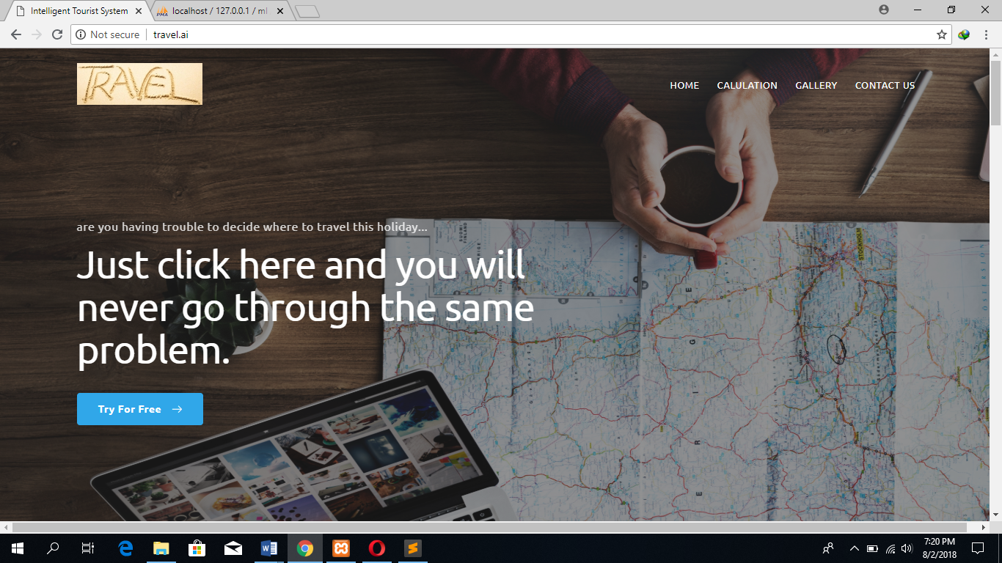

Result display page:

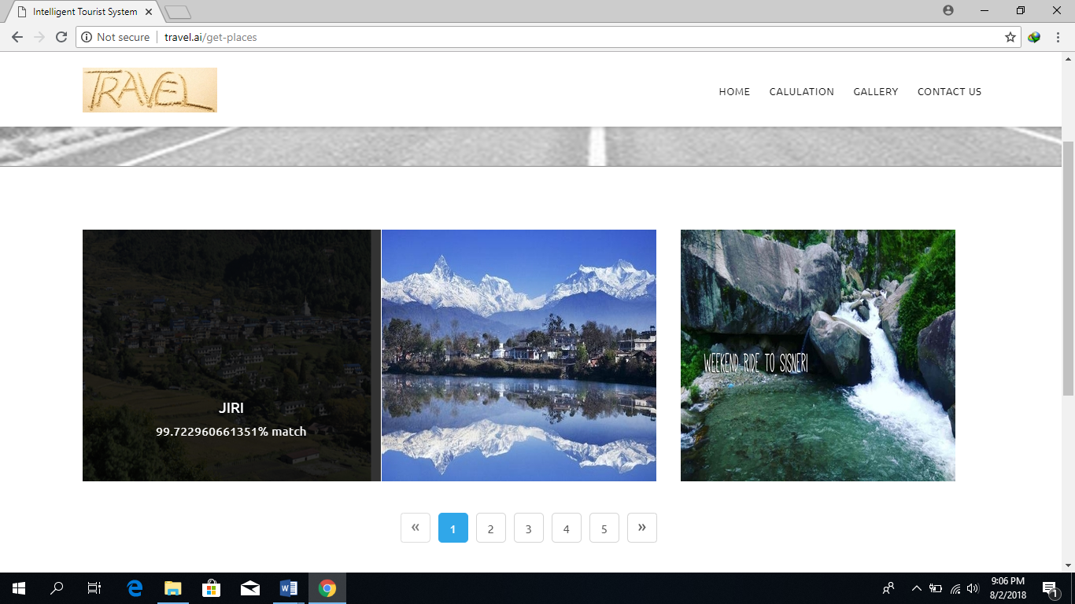

Form to add places by Admin:

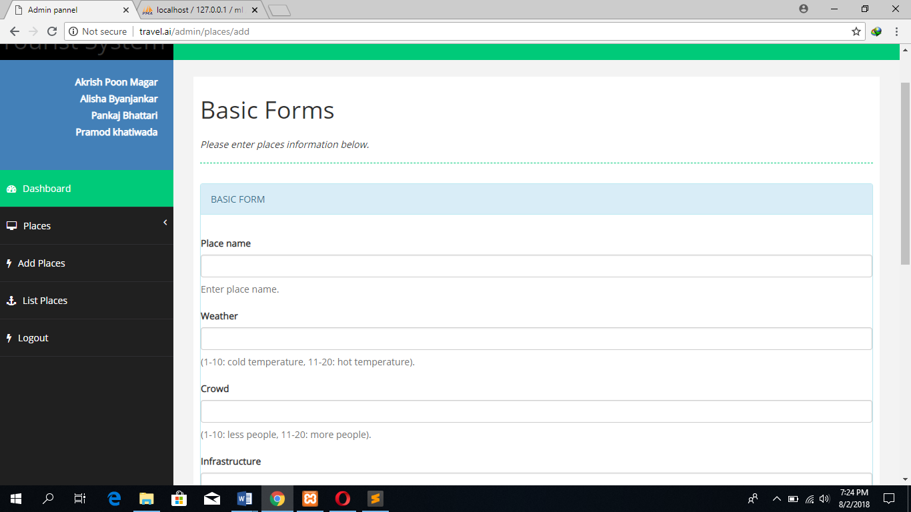

Manage places by Admin:

